2017 Drama 4 College Research Information Sheet
Name of School: Roosevelt University
Number of Students: 5,352 Students. 3,239 Undergraduates 2,113 Graduates
Average GPA/SAT/ACT: 3.16/1170/22
Demographics: 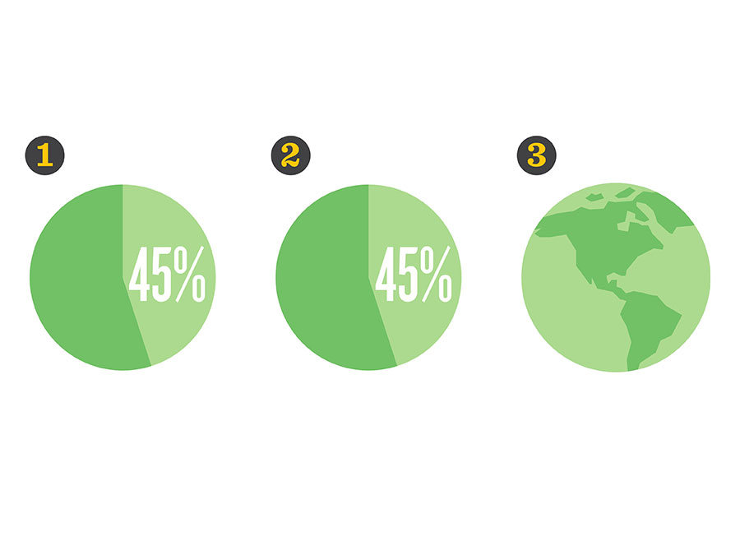
- 45% first-generation students, adding unique culture and experiences to our student body
- 45% students of color
- Approx. 400 international students from 73 countries and a wealth of global perspectives
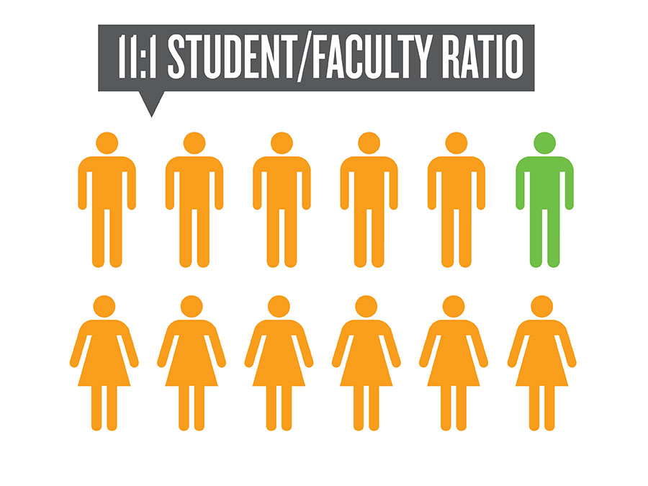
44.7% White
23.3% Hispanic/Latino
17.8% Black/African American
5% Asian
4.6% Non-Residence Alien
2.7% Two or More Races
1.5% Ethnicity Unknown
0.2% American Indian or Alaska Native
Female: 64% Male: 36% of the Undergraduate Class
Tuition/Cost of Attendance (please specify per year/semester, in-state vs. out-of-state):
Full-Time Tuition for 2017-18
Undergraduate (12-18 credits per semester) per Academic Year
Chicago College of Performing Arts $36,734
Room & Meal Rates for 2017-18:
Wabash Building 6 Academic Year Contract:
Single bedroom* $12,299
Double bedroom* $9,227
Triple bedroom* $8,097
Standard meal plan $3,700
* meal plan required
University Center 6 Academic Year Contract:
Single bedroom in 4 bedroom apartment ("Quad 4-bedroom Apt") $13,200
Double bedroom in 2 bedroom apartment ("Quad 2-bedroom Apt") $10,794
Double bedroom in 1 bedroom suite ("Double Deluxe")* $10,242
Double bedroom in 2 bedroom suite ("Quad Semi-Suite")* $9,018
Basic meal plan $2,970
* meal plan required
Application Deadline: Rolling Admissions
Does this school offer a BFA in Acting? Yes!
If so, what are the audition requirements?
AUDITION REQUIREMENTS:
Audition (10 min): Two contrasting monologues from contemporary plays (one comedic, one dramatic). Each monologue should be no longer than two minutes. Characters should be close to your age. If you choose an ethnic piece, the contrasting piece should be ethnically non-specific. Monologues should be performed from memory.
How many students are admitted into the BFA acting program each year? idk
Does this school offer a BFA in Musical Theater? Yes! They also have a BFA in Musical Theatre Dance Concentration!
If so, what are the audition requirements?
AUDITION REQUIREMENTS:
Audition (10-15 min): Two contrasting monologues from contemporary plays (one comedic, one dramatic). Each monologue should be no longer than two minutes. Please note that in most cases, we may only ask you to perform one monologue. Whether you perform one or two monologues is no indication of our admissions decision. In addition, please prepare 32 bars each of one ballad and one up-tempo song from the standard musical theatre repertoire. Do not bring more than 32 bars for each. Characters should be close to your age. All pieces should be performed from memory. All Musical Theatre applicants will begin their audition with a short vocal evaluation/warm-up.
*You must sing with recorded accompaniment. Please bring this recorded accompaniment with you on a mobile device such as a phone or mp3 player. We will provide a speaker and auxiliary input cable to plug your device into a speaker. Recordings should not contain any lead vocals.
Dance Call (1 hour): The dance call will consist of learning a dance in the jazz-style as a large group and then performing this dance sequence in progressively smaller groups. Please be sure to bring ballet flats, jazz shoes, and hard soled character shoes (men)/heeled character shoes (women). Clothing should be form-fitting while allowing for freedom of movement.
How many students are admitted into the BFA musical theater program each year?
Will you require an accompaniment track? Yes!
Does this school require a pre-screen audition video? No! You have to audition in person.
What is the pre-screen due date? There isn’t one.
What are the pre-screen requirements? None.
Will this school be holding auditions at Unifieds? Yes!
Does this school also offer an MFA program?
They do not have an MFA in acting, but they do have...
- Creative Writing, MFA
- Theatre Directing, MA
- Voice, MM
- Performing Arts Administration, MA
- Music Composition, MM
- Piano Performance, MM

If this school offers a BFA program, do they make cuts/have a “re-audition” policy? If so, please discuss.
No

Please discuss the highlights of the training methods offered by this school, including acting, voice, movement and dance techniques that appear to be central to this school’s training.
The BFA in Acting is a pre-professional degree program designed to develop a strong foundation in the skills required for a career as an actor on stage, and in film and television. The acting program provides students with intensive training in several techniques including Stanislavski-based work, Viewpoints, period styles, on-camera technique, circus arts, stage combat, and Linklater voice and body technique. Acting majors also receive training in dance and voice lessons as part of their curriculum. Along with opportunities to perform in mainstage and black box productions, acting majors also have the opportunity to intern at some of Chicago’s most prestigious theatres including Chicago Shakespeare Theater, Steppenwolf Theater Company and Goodman Theatre, and dozens of smaller Chicago theatres.

Please provide any other information you feel may be useful for a student considering this school.
MUSICAL THEATRE DANCE CONCENTRATION, BFA
The BFA in Musical Theatre Dance Concentration is a pre-professional degree program designed to develop a strong foundation in the skills required for a career as a musical theatre performer, focusing particularly on the discipline of dance. The program is a unique blend of Musical Theatre disciplines for the dancer with training in acting, voice and intensive dance studies in Ballet, Jazz, Modern, Tap and Musical Theatre Dance styles. Students in the Dance Concentration will receive specialized training in dance pedagogy, kinesiology, and injury prevention. Dance Concentration students are eligible for casting in musical productions on the mainstage as well as our black box productions.
MUSICAL THEATRE, BFA
The BFA in Musical Theatre is a pre-professional degree program designed to develop a strong foundation in the skills required for a career as a musical theatre performer, focusing particularly on vocal performance and acting technique. The program blends intensive musical training including music theory, piano skills, and weekly voice lessons with a high level of acting coursework in Linklater technique, scene study, and period styles. Students also receive extensive training in ballet, jazz, modern, tap, and musical theatre dance styles. Musical Theatre majors are eligible for casting in musical productions and plays on the mainstage as well as our black box productions.
VOICE, BM
The goals of the Voice program are to train singers who are skilled musicians, performance-ready and technically healthy in their approach to singing, good colleagues, artistically prepared through academic and general coursework and performance opportunities, and knowledgeable about all styles and periods of vocal repertory, including art song, opera, and oratorio.
The program's objectives are to:
Develop technical facility in a systematic fashion, with a common understanding of healthy vocalism that is emphasized across all studios.
Develop progressively the student's collaborative and practical skills.
Develop comprehensive musicianship skills, analytic abilities, and knowledge of musical style.
http://catalog.roosevelt.edu/undergraduate/performing-arts/music-conservatory/
#ChicagoIsOurCampus- Located in the heart of downtown Chicago
200+ Theatres Including five Tony Award Winning Theatre Companies
Second most diverse college in Illinois
Second tallest University building in the United States
Private University
Greek Life:
FRATERNITIES:
Alpha Phi Alpha Fraternity, Inc.
Corey Simpson: corey.simpson92@gmail.com
Phi Iota Alpha Fraternity, Inc.
Florencio Vera: fvera@mail.roosevelt.edu
Phi Beta Sigma Fraternity, Inc.
No current Roosevelt members
SORORITIES:
Alpha Gamma Delta (Beta Upsilon Chapter)
Shelby Steele: ssteele01@mail.roosevelt.edu
Alpha Kappa Alpha Sorority, Inc. (Beta Chapter)
Katherine Childress: kchildress01@mail.roosevelt.edu
Delta Sigma Theta Sorority, Inc.
Patricia Hudson: lambdadst@gmail.com
Gamma Phi Omega International Sorority, Inc. (Iota Chapter)
Lili Martinez: lperezmartinez@mail.roosevelt.edu
Sigma Gamma Rho Sorority, Inc.

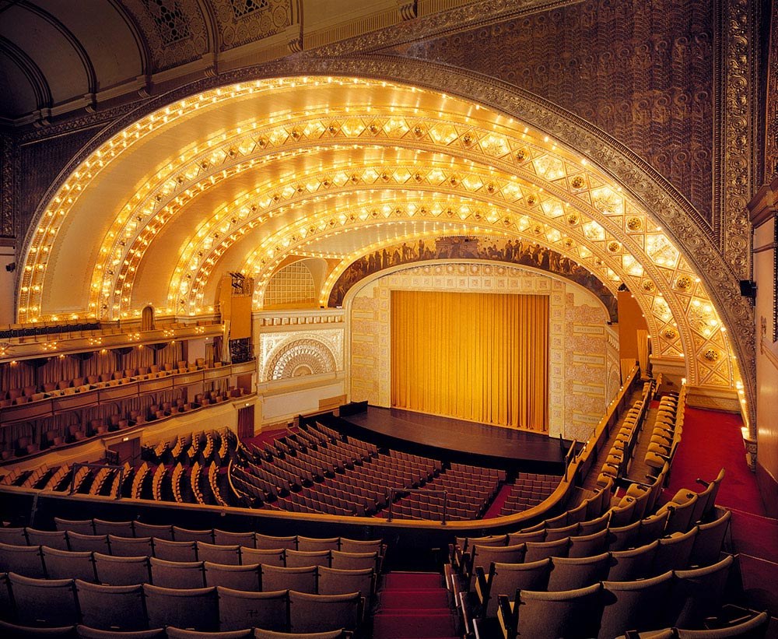
Fala the Laker is the official mascot of Roosevelt University. Introduced to the Roosevelt University community on March 22, 2016, Fala is the Scottish Terrier of President Franklin Delano Roosevelt and Eleanor Roosevelt.

